Nama: M. Abdi Haqya

Tugas: Membuat 10 query SQL

1. SELECT * FROM ‘obat’ ORDER BY Stok_gudang DESC

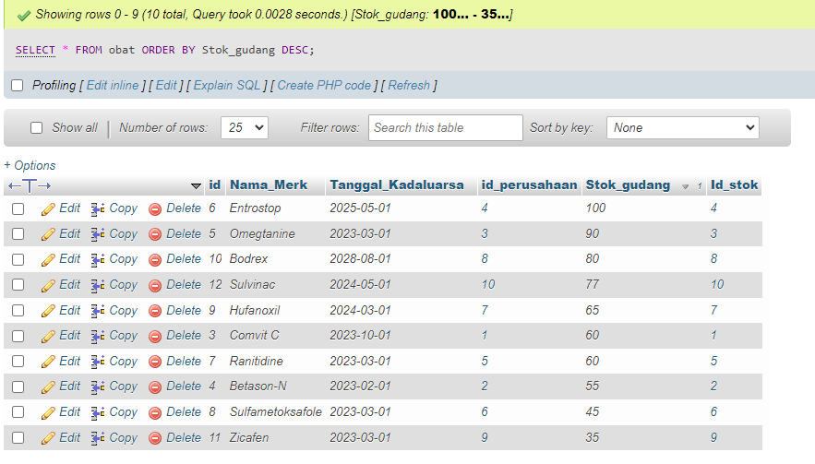

1. SELECT * FROM ‘obat’ ORDER BY Tanggal_Kadaluarsa ASC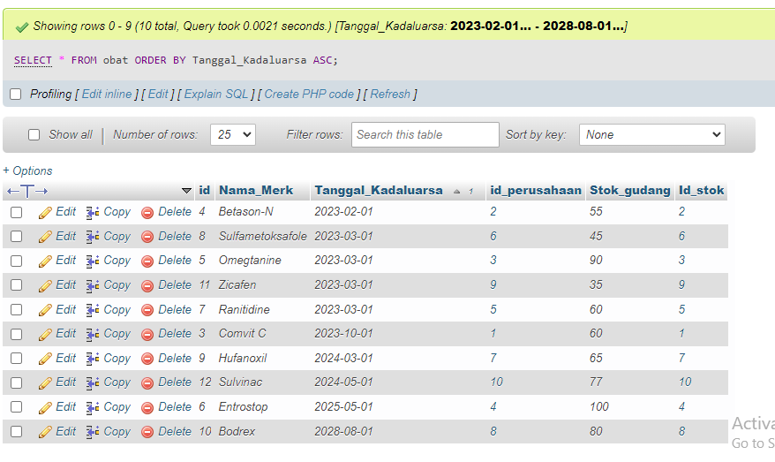
2. SELECT * FROM `obat` WHERE `Nama_Merk` LIKE 'Entrostop'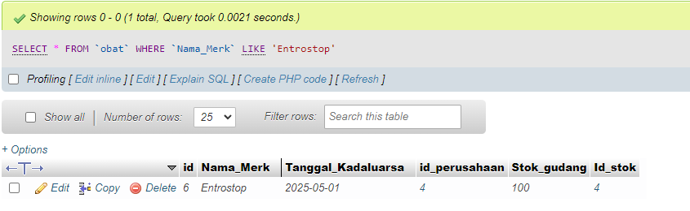
3. SELECT id_perusahaan, SUM(Stok_gudang) as total FROM obat GROUP BY id_perusahaan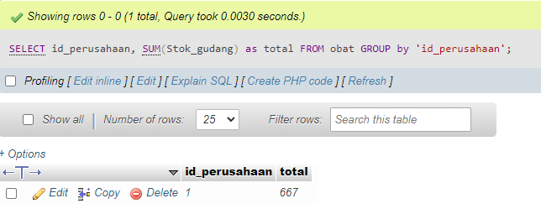
4. SELECT id_stok, SUM(Stok_gudang) as total FROM obat GROUP BY id_stok 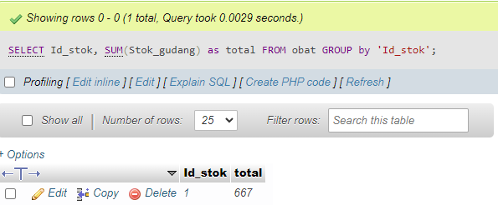
5. SELECT Harga_satuan, SUM(Total_biaya) as total FROM stok GROUP BY 'Harga_satuan' 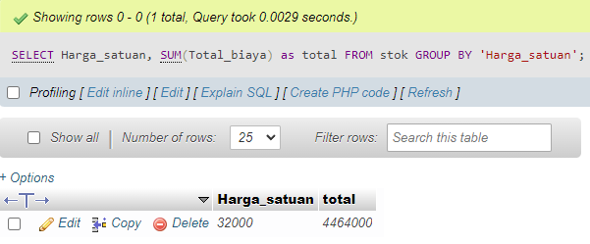
6. SELECT Tanggal_Kadaluarsa, SUM(Stok_gudang) as total FROM obat GROUP BY Tanggal_Kadaluarsa 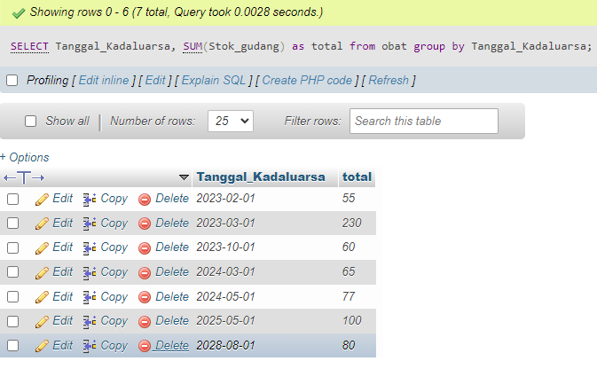
7. SELECT Tanggal_Kadaluarsa, SUM(Stok_gudang) as total from obat where Tanggal_Kadaluarsa >= '2024-01-01' group by Tanggal_Kadaluarsa order by Tanggal_Kadaluarsa DESC 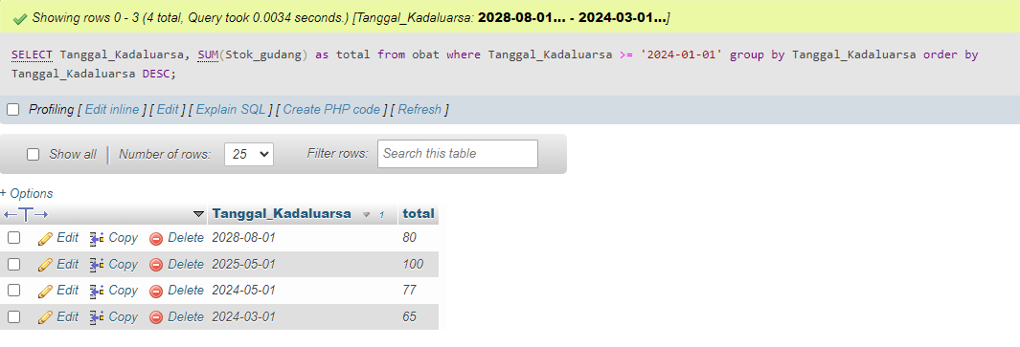
8. SELECT Tanggal_Kadaluarsa, SUM(Stok_gudang) as total from obat group by Tanggal_Kadaluarsa order by Tanggal_Kadaluarsa DESC 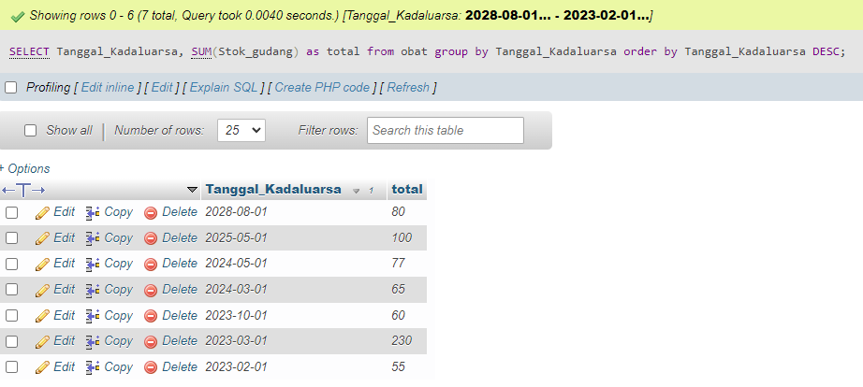
9. SELECT Tanggal_Kadaluarsa, SUM(Stok_gudang) as total from obat group by Tanggal_Kadaluarsa order by Tanggal_Kadaluarsa ASC 